[DOOR-LOCK-SYSTEM--PROTEUS-](https://github.com/19BCS4520/DOOR-LOCK-SYSTEM--PROTEUS-/upload/main)/

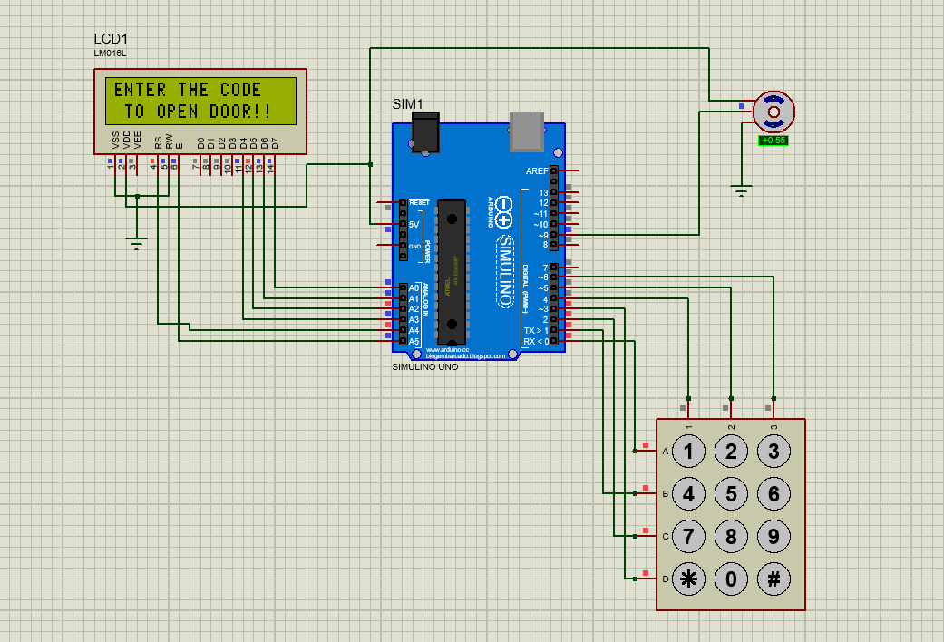

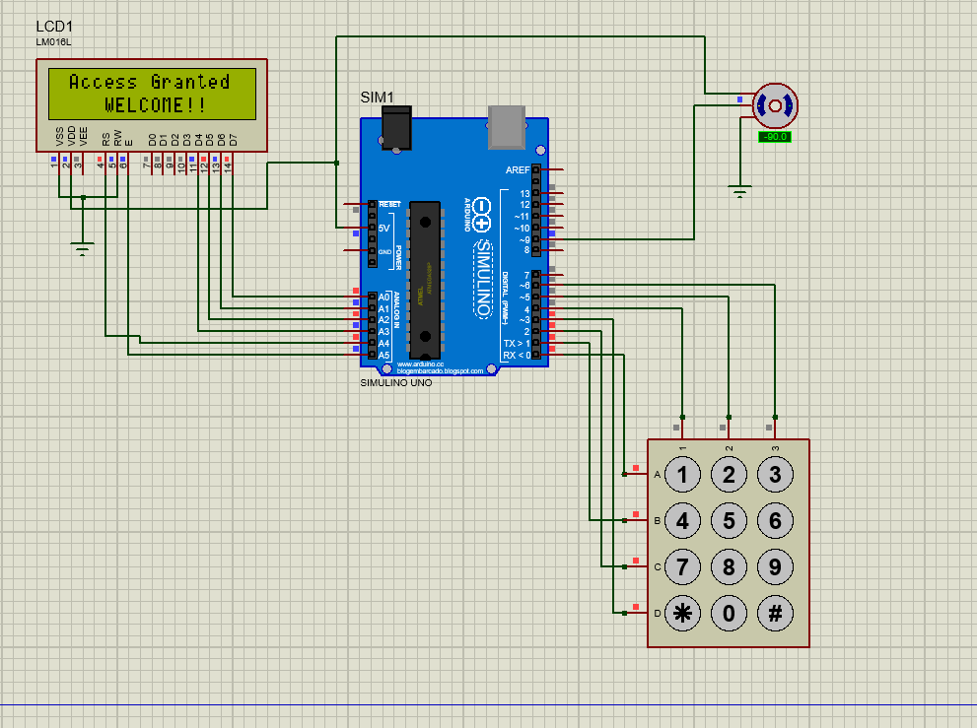

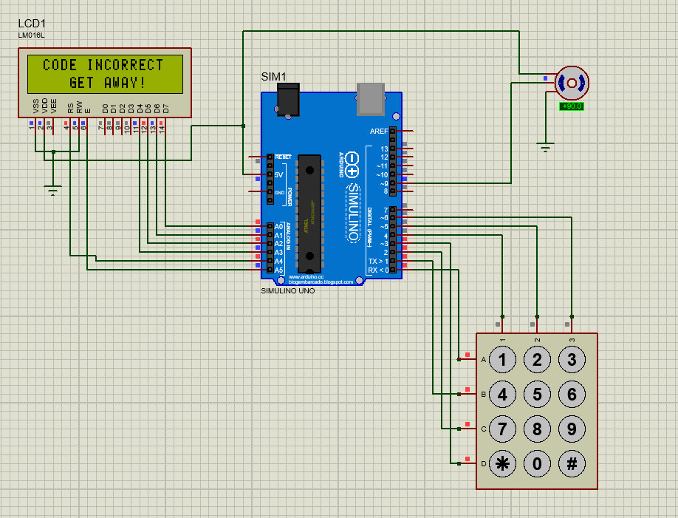Top of Form